Q1. List top 5 customers by total order amount.
Retrieve the top 5 customers who have spent the most across all sales orders. Show CustomerID, CustomerName, and TotalSpent.

Query:
SELECT TOP 5
c.CustomerID,
c.Name AS CustomerName,
SUM(so.TotalAmount) AS TotalSpent
FROM dbo.customer c
INNER JOIN dbo.salesorder so
ON c.CustomerID = so.CustomerID
GROUP BY
c.CustomerID,
c.Name
ORDER BY TotalSpent DESC;
Answer:

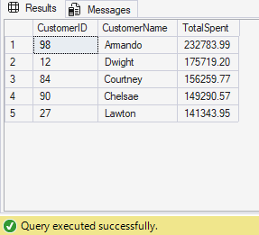

Q2. Find the number of products supplied by each supplier.
Display SupplierID, SupplierName, and ProductCount. Only include suppliers that have more than 10 products.

Query:
SELECT
s.SupplierID,
s.Name AS SupplierName,
COUNT(DISTINCT pod.ProductID) AS ProductCount
FROM dbo.supplier s
INNER JOIN dbo.purchaseorder po
ON s.SupplierID = po.SupplierID
INNER JOIN dbo.purchaseorderdetail pod
ON po.OrderID = pod.OrderID
GROUP BY
s.SupplierID,
s.Name
HAVING COUNT(DISTINCT pod.ProductID) > 10;
Answer:
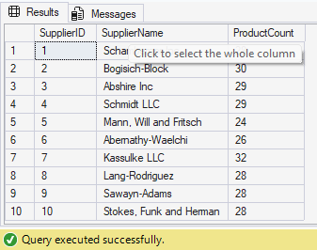

Q3. Identify products that have been ordered but never returned.
Show ProductID, ProductName, and total order quantity.
Query:
SELECT
p.ProductID,
p.Name AS ProductName,
SUM(sod.Quantity) AS TotalOrderQuantity
FROM dbo.product p
INNER JOIN dbo.salesorderdetail sod
ON p.ProductID = sod.ProductID
LEFT JOIN dbo.returndetail rd
ON p.ProductID = rd.ProductID
WHERE rd.ProductID IS NULL
GROUP BY
p.ProductID,
p.Name;
Answer:
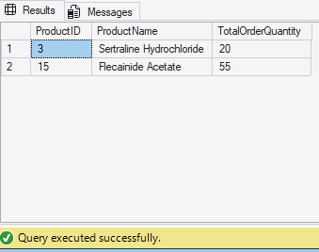

Q4. For each category, find the most expensive product.
Display CategoryID, CategoryName, ProductName, and Price. Use a subquery to get the max price per category.
Query:
SELECT
c.CategoryID,
c.Name AS CategoryName,
p.Name AS ProductName,
p.Price
FROM dbo.product p
INNER JOIN dbo.category c
ON p.CategoryID = c.CategoryID
WHERE p.Price =
(
SELECT MAX(p2.Price)
FROM dbo.product p2
WHERE p2.CategoryID = p.CategoryID
);
Answer:
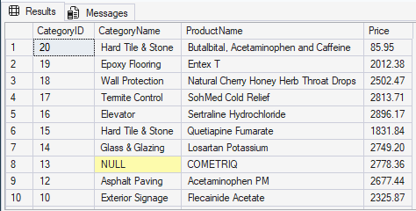

Q5. List all sales orders with customer name, product name, category, and supplier.
For each sales order, display:
OrderID, CustomerName, ProductName, CategoryName, SupplierName, and Quantity.
Query:
SELECT
so.OrderID,
c.Name AS CustomerName,
p.Name AS ProductName,
cat.Name AS CategoryName,
s.Name AS SupplierName,
sod.Quantity
FROM dbo.salesorder so
INNER JOIN dbo.customer c
ON so.CustomerID = c.CustomerID
INNER JOIN dbo.salesorderdetail sod
ON so.OrderID = sod.OrderID
INNER JOIN dbo.product p
ON sod.ProductID = p.ProductID
INNER JOIN dbo.category cat
ON p.CategoryID = cat.CategoryID
INNER JOIN dbo.purchaseorderdetail pod
ON p.ProductID = pod.ProductID
INNER JOIN dbo.purchaseorder po
ON pod.OrderID = po.OrderID
INNER JOIN dbo.supplier s
ON po.SupplierID = s.SupplierID;
Answer:
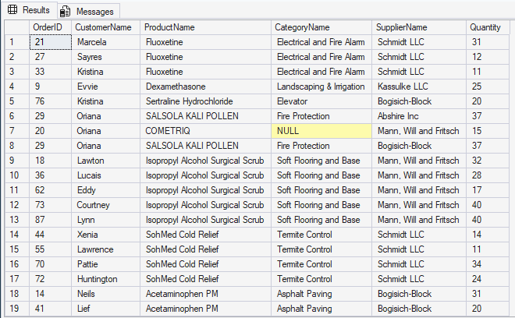

Q6. Find all shipments with details of warehouse, manager, and products shipped.
Display:
ShipmentID, WarehouseName, ManagerName, ProductName, QuantityShipped, and TrackingNumber.

Query:
SELECT
sh.ShipmentID,
l.Name AS WarehouseName,
e.Name AS ManagerName,
p.Name AS ProductName,
sd.Quantity AS QuantityShipped,
sh.TrackingNumber
FROM dbo.shipment sh
INNER JOIN dbo.warehouse w
ON sh.WarehouseID = w.WarehouseID
INNER JOIN dbo.employee e
ON w.ManagerID = e.EmployeeID
INNER JOIN dbo.location l
ON w.LocationID = l.LocationID
INNER JOIN dbo.shipmentdetail sd
ON sh.ShipmentID = sd.ShipmentID
INNER JOIN dbo.product p
ON sd.ProductID = p.ProductID;
Answer:
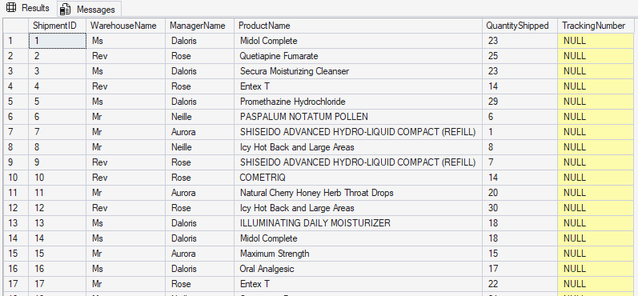

Q7. Find the top 3 highest-value orders per customer using RANK(). Display CustomerID, CustomerName, OrderID, and TotalAmount.
Query :

WITH RankedOrders AS
(
SELECT
c.CustomerID,
c.Name AS CustomerName,
so.OrderID,
so.TotalAmount,
RANK() OVER
(
PARTITION BY c.CustomerID
ORDER BY so.TotalAmount DESC
) AS OrderRank
FROM dbo.customer c
INNER JOIN dbo.salesorder so
ON c.CustomerID = so.CustomerID
)
SELECT
CustomerID,
CustomerName,
OrderID,
TotalAmount
FROM RankedOrders
WHERE OrderRank <= 3
ORDER BY CustomerID, TotalAmount DESC;
Answer:
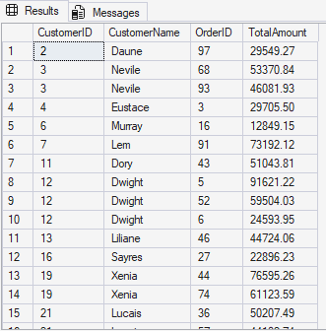

Q8. For each product, show its sales history with the previous and next sales quantities (based on order date). Display ProductID, ProductName, OrderID, OrderDate, Quantity, PrevQuantity, and NextQuantity.

Query:
SELECT
p.ProductID,
p.Name AS ProductName,
so.OrderID,
so.OrderDate,
sod.Quantity,
LAG(sod.Quantity)
OVER
(
PARTITION BY p.ProductID
ORDER BY so.OrderDate
) AS PrevQuantity,
LEAD(sod.Quantity)
OVER
(
PARTITION BY p.ProductID
ORDER BY so.OrderDate
) AS NextQuantity
FROM dbo.product p
INNER JOIN dbo.salesorderdetail sod
ON p.ProductID = sod.ProductID
INNER JOIN dbo.salesorder so
ON sod.OrderID = so.OrderID
ORDER BY p.ProductID, so.OrderDate;
Answer:
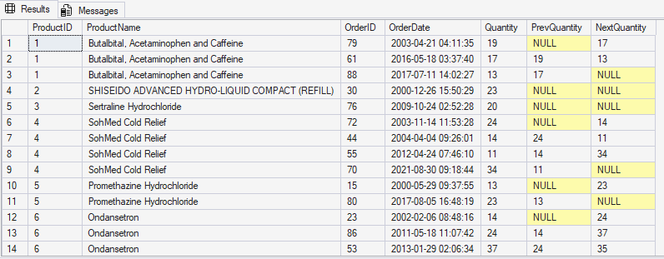
Q9. Create a view named vw_CustomerOrderSummary that shows for each customer:
CustomerID, CustomerName, TotalOrders, TotalAmountSpent, and LastOrderDate.
Query:
CREATE VIEW dbo.vw_CustomerOrderSummary
AS
SELECT
c.CustomerID,
c.Name AS CustomerName,
COUNT(so.OrderID) AS TotalOrders,
SUM(so.TotalAmount) AS TotalAmountSpent,
MAX(so.OrderDate) AS LastOrderDate
FROM dbo.customer c
LEFT JOIN dbo.salesorder so
ON c.CustomerID = so.CustomerID
GROUP BY
c.CustomerID,
c.Name;
GO

SELECT *
FROM dbo.vw_CustomerOrderSummary;

Answer:
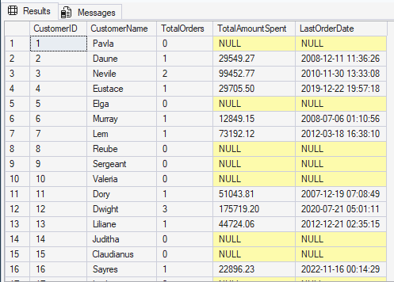

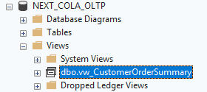

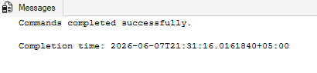

Q10. Write a stored procedure sp_GetSupplierSales that takes a SupplierID as input and returns the total sales amount for all products supplied by that supplier.

Query:

CREATE PROCEDURE dbo.sp_GetSupplierSales
@SupplierID INT
AS
BEGIN
SET NOCOUNT ON;

SELECT
@SupplierID AS SupplierID,
SUM(sod.TotalAmount) AS TotalSalesAmount
FROM dbo.supplier s
INNER JOIN dbo.purchaseorder po
ON s.SupplierID = po.SupplierID
INNER JOIN dbo.purchaseorderdetail pod
ON po.OrderID = pod.OrderID
INNER JOIN dbo.product p
ON pod.ProductID = p.ProductID
INNER JOIN dbo.salesorderdetail sod
ON p.ProductID = sod.ProductID
WHERE s.SupplierID = @SupplierID;
END;
GO
EXEC dbo.sp_GetSupplierSales @SupplierID = 1;

Answer:
